The Sixth Estate: Artists and Social Change
Forthcoming in Traces, a magazine of the Swedish Arts Grants Committee’s International Programme for Visual and Applied Artists (2022).
Author: Marisa Angell Brown

Can art be liberatory?

Can artwork or stories (to follow Saidiya Hartman) be a form of reparations?

Can art take us past the limits of history and the archive, into the real?

Can art tell a counter-history to the versions of history that we once accepted as fact (again, Saidiya Hartman)? Are artists actually the best at showing us all of the potential of our post-history state?

These are some of the questions of the day—and they certainly put a lot on the shoulders of artists, don’t they? It’s like we arrived at this precipice through hundreds if not thousands of years of human labor, ingenuity and violence (always violence), each generation creating ever more powerful ways of extracting…fossil fuels from the earth, voluntary and involuntary forced labor from each other…and now suddenly, we are being called to account. Our generation and the next and the next (and the next?) is getting the bill, and it looks like there is no way that it can be paid, or maybe the real issues is not that it can’t be paid, but that we don’t want to pay it. Rather than change our lives, our economy, or our culture, it’s so much easier, isn’t it, to create a commission that pays an artist less than a living wage to create work that absolves us of changing anything? On the other hand (because I believe deeply in the arts), will the works of art created today and tomorrow save us?

In school, we learned about power and how it was distributed this way: the “first estate” was the Catholic clergy, the “second estate” was the aristocracy, the “third estate” was the people, and the “fourth estate” was the press. About twenty years ago, the “fifth estate” got added to the chain: bloggers and other alternative writers/journalists. Here is my question: are artists the “sixth estate”? Have artists come to have such a significant role in critiquing the world order—and not only critiquing, but suggesting/revealing liberatory alternatives (with the rise of social practice art)—that we might start thinking about artists in this way? Does that make art seem less interesting, more dull, just another lobbying group in the balance of power? Or does it feel uplifting, does it give hope, and does it elevate the power of art? Maybe all of this saving isn’t exactly what artists bargained for. But when I read the newspaper every day I’m not seeing anyone else up to it.

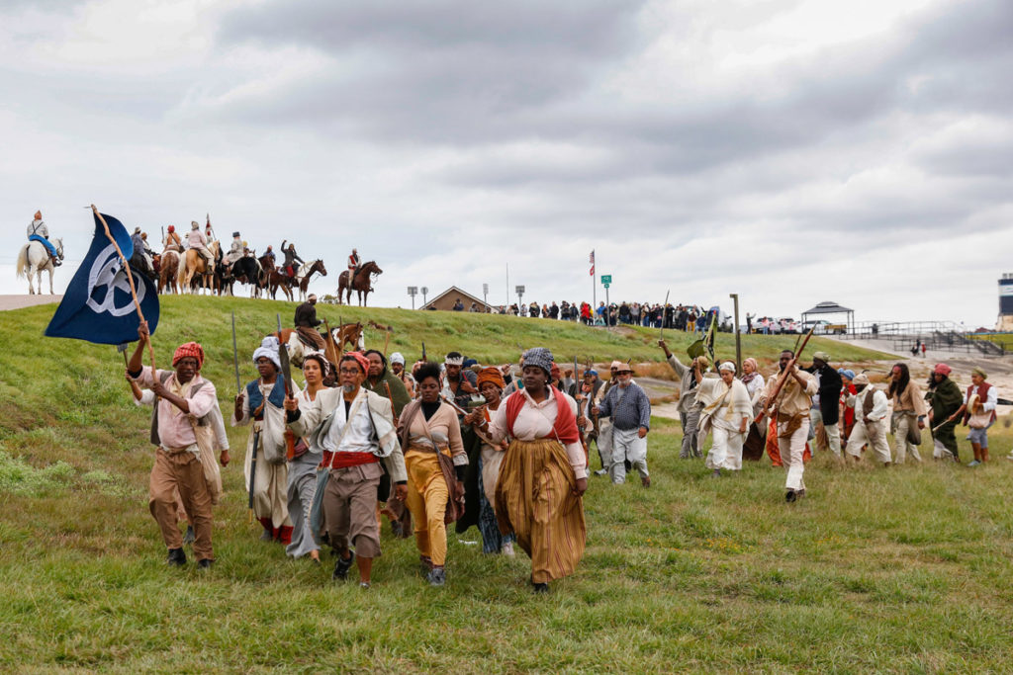
Dread Scott’s November 2019 reenactment of the German Coast Uprising of 1811, which included 400 performers restaging the largest ever slave rebellion in US history over a 2-day march through Louisiana.

